**Project -Library Management System**

**Module –User and Admin login, user and admin creation and some other functionalities**

**Name** – Archit Garg **Emp ID:** 46002022

**Package Name –** Z46002022library **Tcode-** Z46002022login

**Asumptions**

1. User can create their account by themselves as well as admin can create multiple user account for batch registration.
2. Books Issue, Return, fine calculation, books ordering and payments are the other modules which were done by other team members.

**Admin Table** – I have taken fewer fields for admin because admins are the librarians and their data must be there with the company who is employing them.

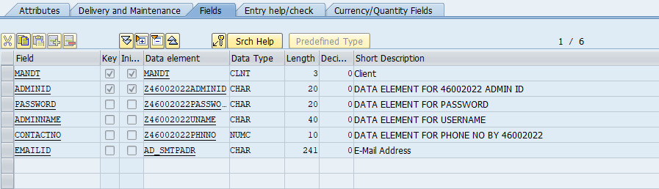

**User table**

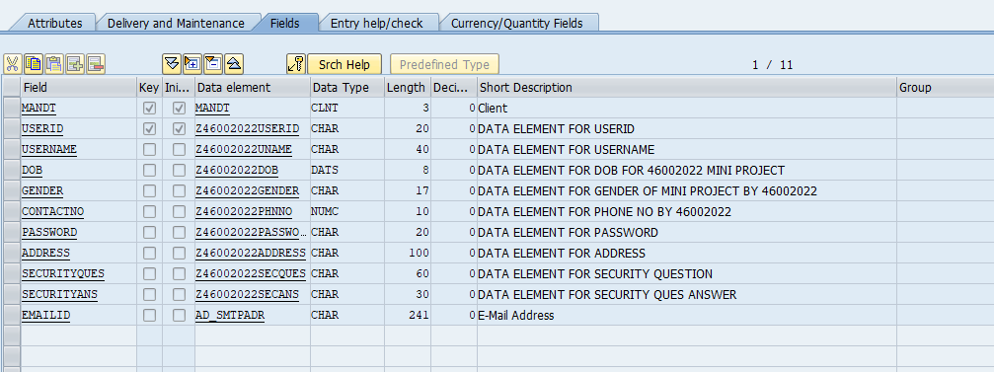

**User login screen**

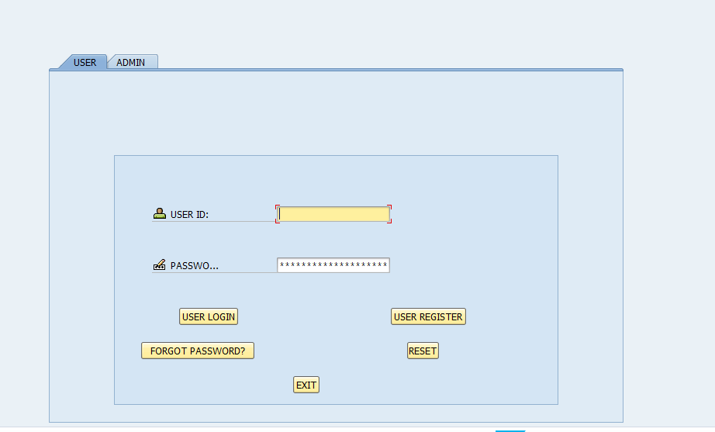

**User login screen field checks**

When user tries to login without entering a password then there is a field check.

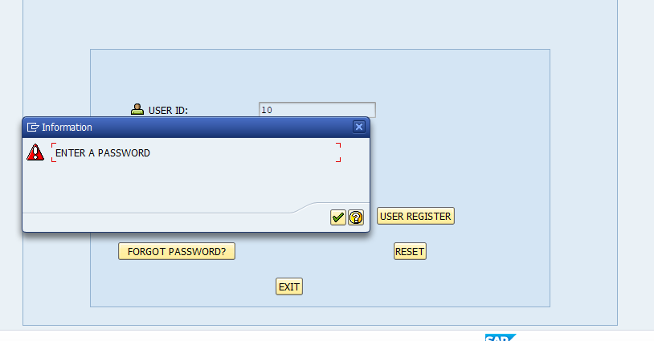

When user entered invalid ID or password pop-up appears

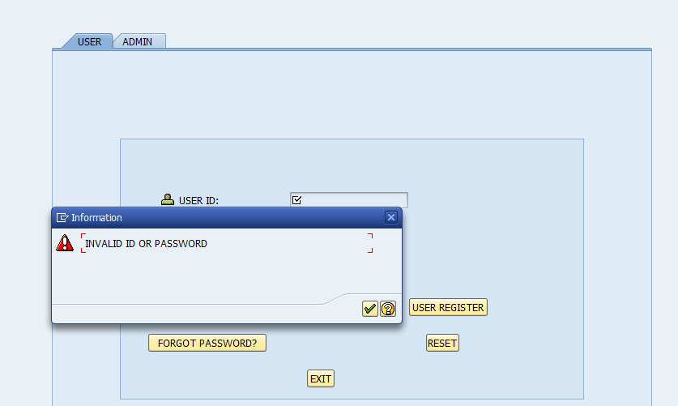

**User Registration Screen**

From Main User Screen when user clicks on USER REGISTER this screen will open wherein I’ve made all fields compulsory and applied necessary field checks wherever required

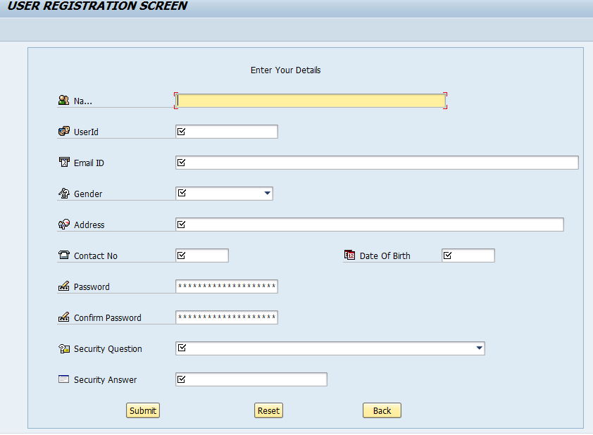

User Registration Screen Dropdown linking to Database Table

Security Question field is being fetched from Domain itself

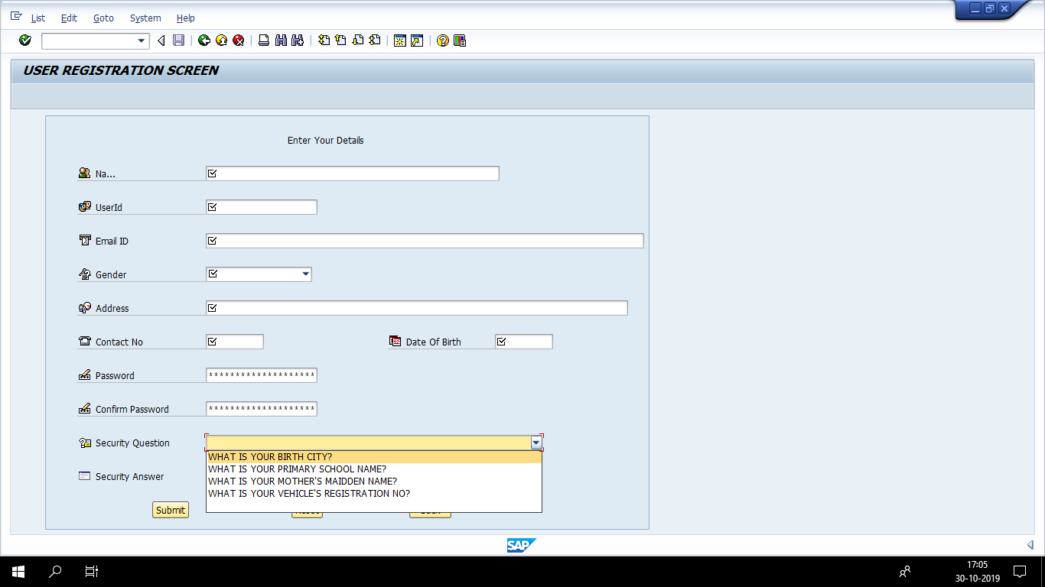

User creation field checks - Similar validations are used for all fields

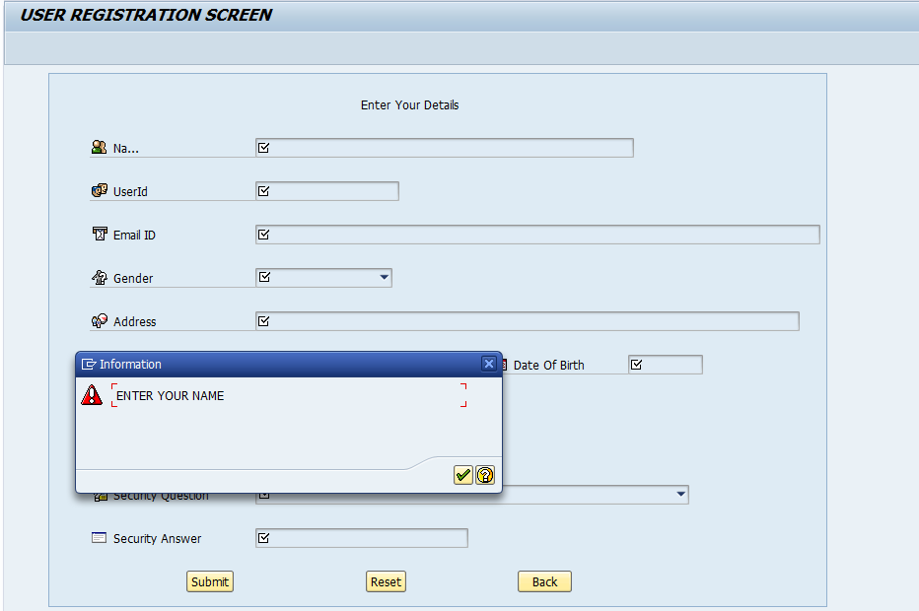

Using Calendar for Date fields

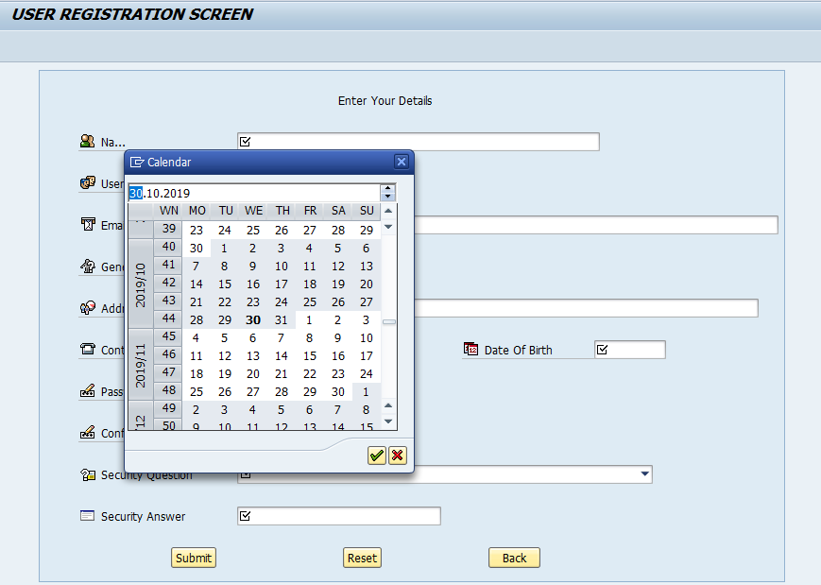

USER FORGOT PASSWORD SCREEN

From main user screen when user clicks on Forgot Password this screen comes up wherein the security question chosen by the user will be used as user identification.

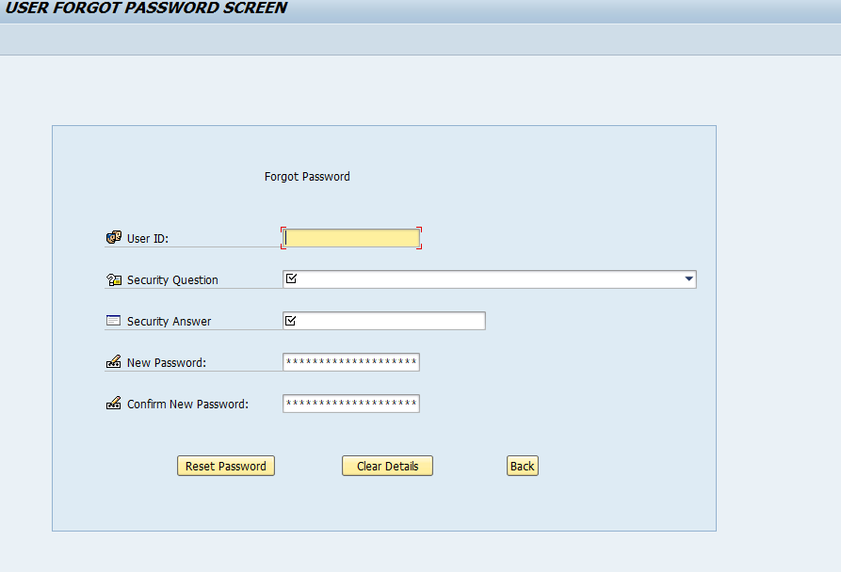

**User Screen**

When user logins this will be the user dashboard wherein user have the option to view and update his/her profile and log out.

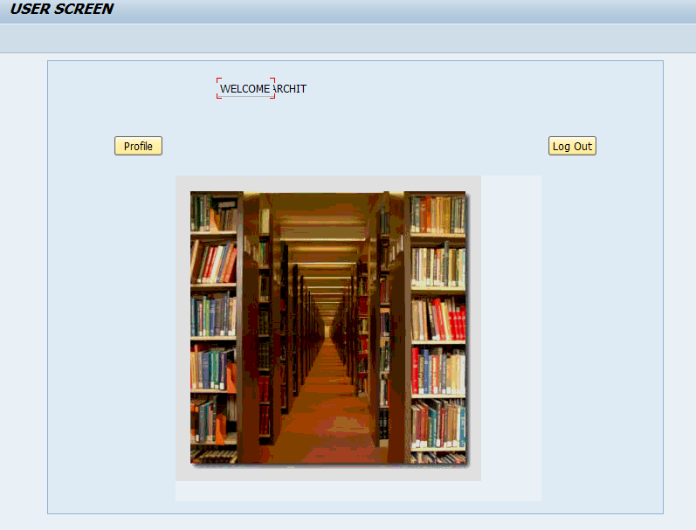

**User Profile Updation Screen**

When user wants to update the profile this screen will be shown

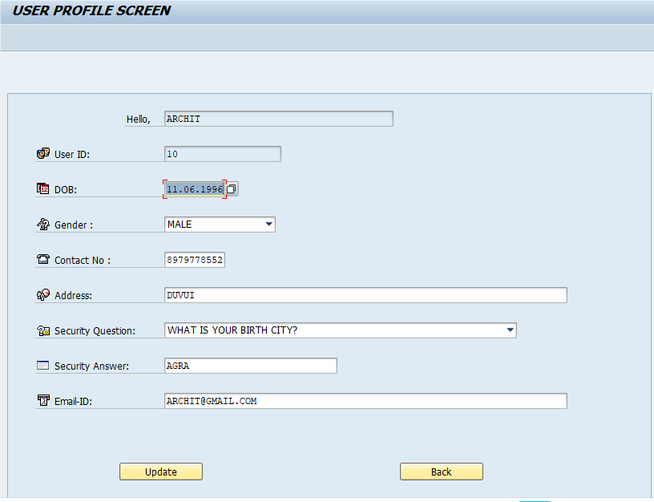

Admin Login Screen

On second tab of tabstrip admin can login

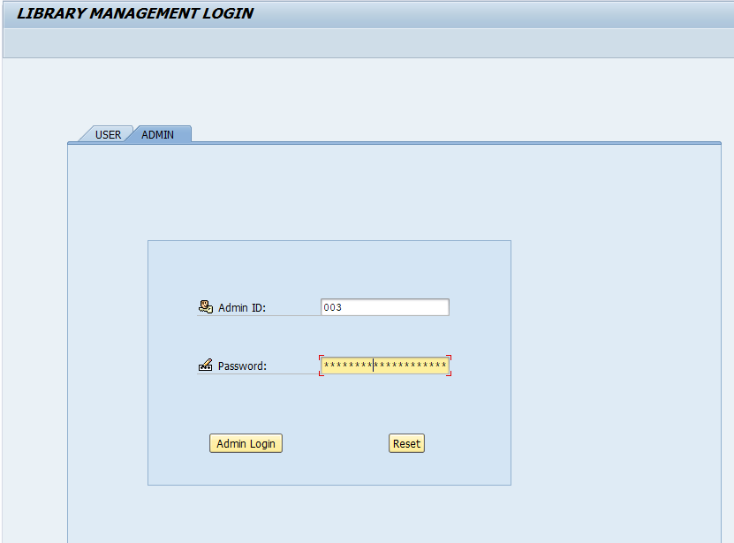

ADMIN SCREEN

When admin logins this will be the dashboard

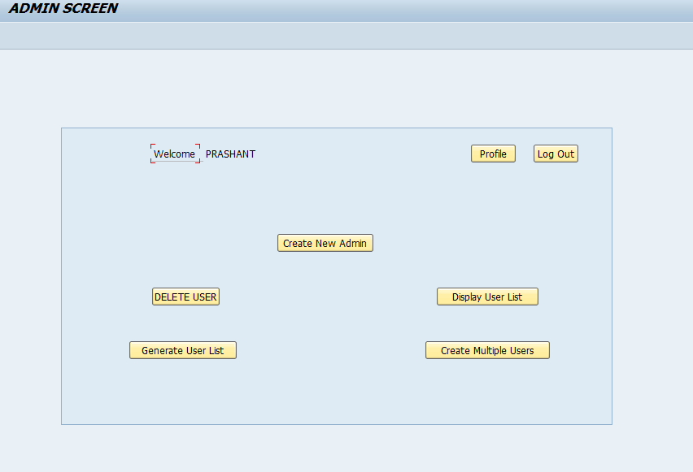

ADMIN CREATION SCREEN – AFTER CLICKING ON CREATE NEW ADMIN

I’ve given the admin creation authority to existing admin only; no random user can register as an admin.

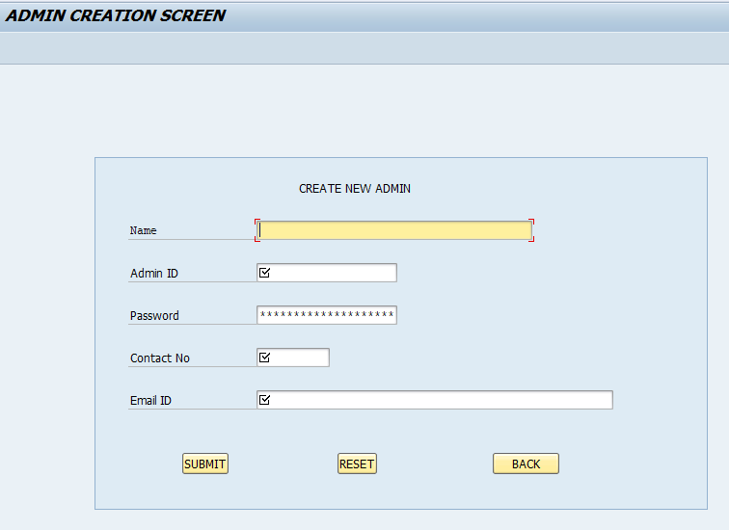

USER DETAILS OOALV- After clicking on Display User List

From main admin dashboard when admin clicks on user details an OOALV is shown with all user info except for user sensitive information.

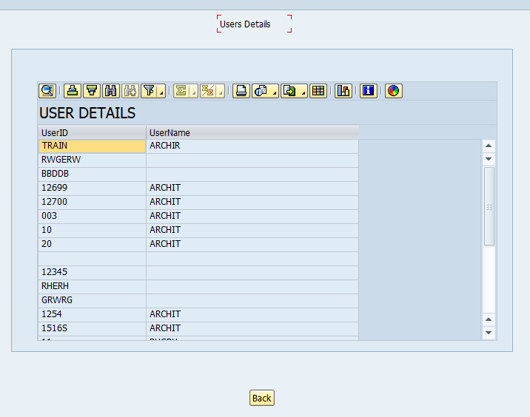

When admin double clicks on any user from OOALV full details of that user will be shown

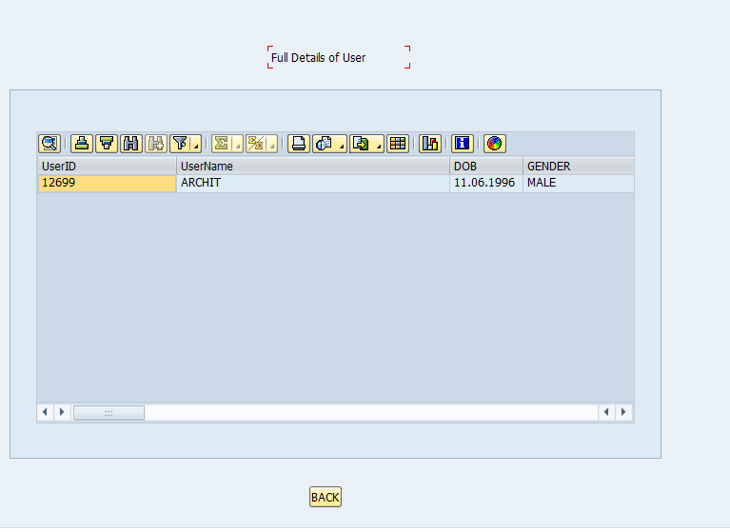

User Deletion Screen- Admin has the right to delete a library user

From admin dashboard admin has the right to delete any user when admin clicks on Delete User, this screen is shown

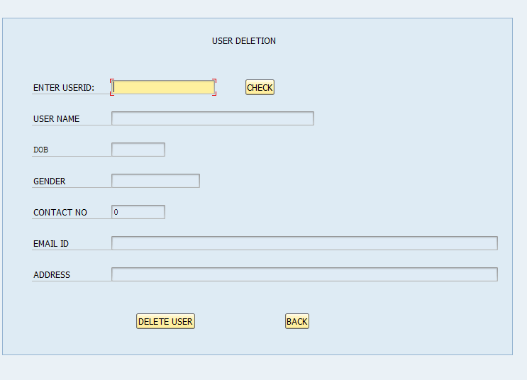

Adobe Form created after clicking on generate user list

When admin clicks on generate user list an adobe form is printed showing the list of user and it will also show the name of admin who has printed these details; appropriate footer is applied at last page of form.

